## Side Scrolling Shooter Game

3rd year Project

2015-2016

Detailed Project Proposal

Ian Doherty – X00103407

Gavin Hickey –X00109563

## Project Background

## When we got together to start this project and were trying to come up with ideas on what to do we both felt we should do something in relation to what we both have an interest in and after a few ideas being thrown around we landed on a game as we both grow up playing all types of games and feel we would know what gamers would want in a new game in development. We both have a love of the old side scrolling shooter games and decided they are no longer in development anymore and we would like to make the side scroller we both have been waiting for.

We have both expressed desires to possibly go into game development after college and want to give it a shot to see how well we can do it and how much we would like it. We decided to use development kits in the process of this project as this is our first time delving into this type of application. With the game we have chosen to make it will be very scalable so that we can start small and work our way up to what the gaming community would consider a fully flushed out game

## Objectives

Our Objectives are as follows:

* To create a side scrolling shooter game.
* Create and source our soundtrack.
* Design and source our background designs and characters
* Design levels according to difficulty.
* Create tutorial pop ups in game
* Create boss fights
* Design and create scoreboards
* Research and create co-op multiplayer elements
* Design and create power ups in game
* Design and create different difficulty setting for the game.
* Create different characters and allow selection and unlocking of those characters.

**Technical Requirements and Risk Assessment**

Our project will have a number of technical requirements which includes:

* We will be using the unity game engine as the development platform.
* An SQL-Server for leaderboards and character loadouts.
* We plan on using the eclipse compiler for java but our programming language could change if we find it better to use another one.
* An application for creating the graphics we will use Photoshop 2014.
* A Wacom Intuos Manga tablet for use as a drawing pad.
* We will be searching for free sources for music and sound along with trying to make our own.
* We will be testing the game on a varied amount of machines to test for graphical and performance differences.
* We will be searching for as many tutorials as we can which if we use java will be hard to find based on our initial searches.

We currently are finding it easy to source most of the above technical requirements but are struggling to find good tutorials for java based games as they are not the usual language for game development and if we cannot find suitable resources we will be forced to change the language to the more common ones for game development such as C#. If this is the case it will add a new language to our current pool of development languages which will stand to us in the future.

Currently the only risks we can find would be if we have to change which we will take in our stride and learn from the many recourses available to us. We must have our time management up to scratch in order to make all course deliverables and our own personally set ones to have the project on course to be the best we can make.

The choice of making a game could be thought of as a risk in that it is not in the college curriculum and we will have a lot of learning to do for the mechanics and graphics of the system but we both have a love of gaming and it is a project that we will enjoy doing throughout development.

## Prototyping & Testing

Our Plan is to have a working prototype by January 16th 2016 Before this time we are focusing on the main foundations of what the videogame will contain. Using the ideas that we have decided upon we have finalized the first level of the prototype.

The game itself will be a 2D shooter (Idea 1) and so the overall design of the game will adhere to the 2D design.

Some sourced inspiration

We have decided to base the level in a downtown city during night time, the background including motorways, alleyways and city buildings of various sizes. The background will be designed using inspiration from various sources. These sources will include different video games, our own ideas and even real world locations. The background will be designed to change as the game progresses to show the player that are making progress and so the background does not become stale and ignored by the player.

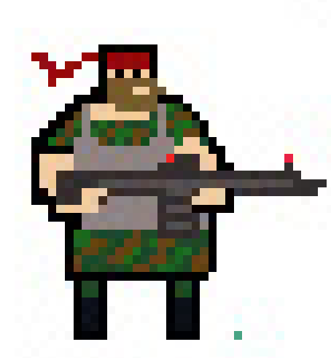Prototype created using Photoshop.

Character design will be sprite based so as to stay to our old retro game inspiration. This will also include the weapons used in the game and enemies as well. Our character will be designed by us to fit a variety of ideas we have come up with and we hope to create character that the player can choose from and even unlock. Some of these characters might include a commando, a ninja or even a clown. We hope also to design the enemies to vary as well with some templates being using but with slight changes that will match the enemies difficulty to defeat, such as colour and size changes. We hope to have different enemies for different areas of the game, such as aliens zombies and ninjas too.

# 

# **Project Methodology**

We would like to design our own design assets but will leave room to source items that we feel would benefit the project more If we found them to be better. The design of the game will be worked on by ourselves to give it a more personal quality. To do this we will be studying pixel art as well as tutorials on how to make our own, and by using Adobe Photoshop 2014 will be designing it ourselves the program has already been edited to have a pixel art template for more precise drawing features as well as using a digital graphics tablet to design some more intricate designs. Though this might be difficult to do we will keep an account as to when a certain design is taking too long and must be sourced instead so that the projects progress is not held up on one single piece of work.

The level design will also be pixelated to keep with the theme of the game but also to alleviate the work load as designing something more intricate like a 3D model has been decided to be too time consuming and difficult to learn. For now we will be focusing on simple designs so that we can work on more functionality such as movement for example character and enemies movement jumping and possible shooting as well. A small bit of animation has been decided upon as we believe that we would like to focus more on the playable functions rather than the graphics so small animation of movement like jumping and running. Sprite animation will work best here for us.

## 

## Project Approach

The way we plan to achieve our objectives is by carefully planning out each stage of the development in order to be more organised and have goals set for each other on what we will have to work on at any given time. By allowing one another to have set roles on different part of the project it means the responsibility and work load is distributed equally.

We make it an obligation to have regular meetings as group partners in order to outline the progress we have made on the project, what areas need to be worked on and any new ideas that might be considered to help improve the project as a whole.

Research is keys and so each member is given different areas to look up and different stage of development, whether it be coding or art design. We plan to have more research done into the areas of game development we are not already familiar with, we will be looking up software and methods of development take can help us achieve our goals and develop the game in a more productive manner.

We have chosen to focus more on our games functionality and gameplay rather than other aspects such as story and graphical design. Of course the game will be designed with our own ideas so as to fit with our retro 2d scroller scheme but we chose to not put too much emphasis on the story line and choose to make the game more fun. We want players to have fun primarily and so we would like to make different gaming functions as mentioned in our objectives like power ups and different playable characters.

**Project Plan**

We both would like to get a start on the prototype as soon as possible because if we make a good start it will put us in a great position for the rest of the project. We have decided on the stages we will start with which are:

1. We will both be getting all developer environments set up on our own computers along with all libraries we have found to help us and any add on to the environments that we will be using but we will be adding more components as we find them.
2. We will be making all the basic GUIs for menus in this stage along with sprite design and creating level very basic levels with the spawn points for non playable character (NPC) enemies.
3. We will do the coding that will make the level work with character movement and weapon functions, enemy NPC spawning and weapon damage to both the player and NPC and we will be adding in level looping to that the background will be able to cycle through.
4. From this point we will be just adding and refining all other components which would be different characters with different stats more NPCs some of the more complex parts of the game such as leaderboards and in game multipliers. After this stage we will be able to use this level as a template for all others which will make it easier going forward.

By the end of these phases we hope to have a fully function prototype of our game which will have all the major mechanics of the full game but still have room for improvement for us to finish after the initial prototype is done.

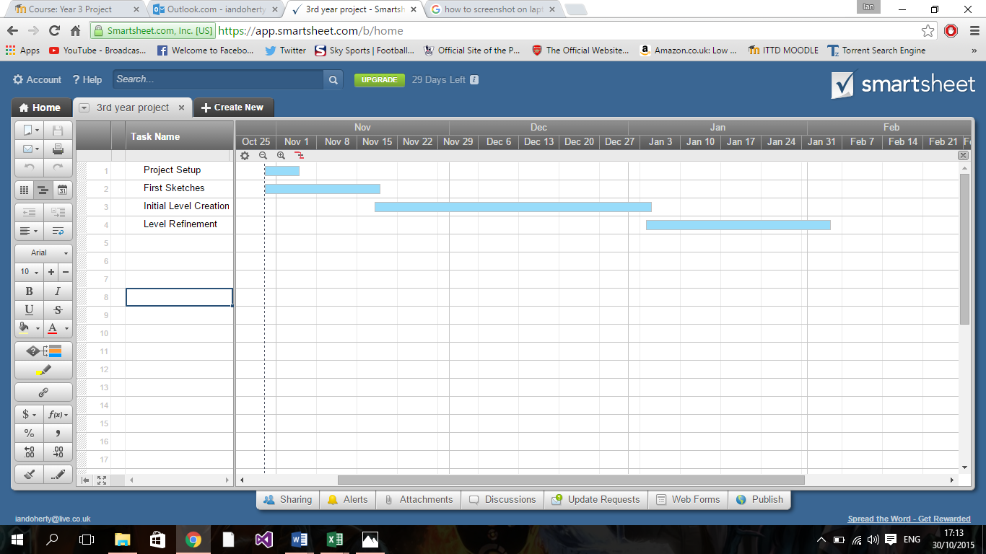

The above Gantt chart shows the time our projected timeframe for everything to be done.

**Conclusion**

We know the work load of this project will be more than what may be asked of a usual game but we still will carry on working towards of ideas and goals through out and with each one of these ideas being accomplished we hope to add more details to the game to make it even better for the player to enjoy. We have a passion for this project and enjoy coming up with ideas that we can work towards. Once the prototype is up and running we believe we can use it to work on the better functionality of this project. We will be having our own deadlines for where we wish things to be done so as to keep us focused and productive.

With hard work and research we hope to complete a a fully developed, fun and retro side scrolling shooter.

**References:**

Pixel art - <https://www.pinterest.com/pin/55521007881740028/>

Tutorial used to create our own pixel art -

<http://design.tutsplus.com/tutorials/how-to-create-an-animated-pixel-art-sprite-in-adobe-photoshop--cms-20428>

**Conclusion:**

We know the work load of this project will be more than what may be asked of a usual game but we still will carry on working towards of ideas and goals through out and with each one of these ideas being accomplished we hope to add more details to the game to make it even better for the player to enjoy. We have a passion for this project and enjoy coming up with ideas that we can work towards. Once the prototype is up and running we believe we can use it to work on the better functionality of this project. We will be having our own deadlines for where we wish things to be done so as to keep us focused and productive.

With hard work and research we hope to complete a a fully developed, fun and retro side scrolling shooter.